Community Grants

We invest in our communities every day, by maintaining homes, building new homes, supporting diverse customers and by funding various activities and projects.

Our believe housing community grant scheme supports projects that make a real difference to people’s lives and wellbeing. We welcome applications from not-for-profit and voluntary organisations as well as local schools, town, parish, or community councils.

The grant scheme has been created to tackle:
- health and wellbeing issues
- improve access to employability or training
- increase household income
- encourage a greener and fairer future
- and tackle inequalities as a result of the coronavirus pandemic.

Projects that could benefit include:
- initiatives to promote better physical and mental wellbeing through arts and crafts or exercise
- youth engagement activities
- family activities and food provision to tackle holiday hunger
- projects that upskill people

Organisations that can apply include
- Registered and exempt charities
- Community groups
- Schools
- Social enterprises
- Voluntary groups
- Community Interest Companies
- Town, Parish or Community Councils

We have four funding streams available £500, £1000, £5,000 to £10,000 revenue grant and £10,000 to £20,000 capital grant:

Small Community Grant
Up to £500 available to cover revenue costs.
A previously funded project was:
Haswell Mencap has supported 50 families who faced the challenge of being alone during the pandemic. Their ‘booster bus project delivered activity packs direct to the homes of those that needed them in the east Durham area. The packs provided entertainment for people with learning disabilities. They were full of hands-on activities, and everything needed to complete them. The packs also gave a welcome break to family members, many of whom are carers 24 hours a day during the coronavirus outbreak.

Small Community Capital Grant
Up to £1,000 available to cover revenue costs and up to 60% capital costs.
A previously funded project was:
We funded CALM in East Durham CIC for a range of resources to allow them to deliver exercise classes to participants that wanted to do face to face activities rather than online, people that wanted to be involved online only this enabled them to offer a mixed session of both ZOOM activity and face to face activities.

Large Community Grant
£5,000 - £10,000 available for revenue projects. Opens next 1st July 2022
Examples of previously funded project are:
East Durham Trust – Villages Family Project

East Durham Trust were awarded £10,000 in March 2020 to help deliver food related family activities to support local families potentially living in financial hardship. Co-ordinated by Shotton Community Hub and Wingate and Station Town Family Centre, 50 sessions were held during the height of the pandemic, supporting 326 and providing 1850 meals.

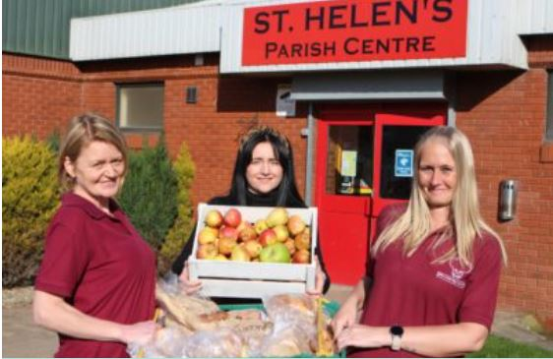
Little Chef, Big Chef – LCBC Community Pantry

A project based in St Helen Auckland set up to tackle poverty and reduce food waste by offering better use of food and offering low-cost items to the local community. The pantry offers safe on-site shopping and in 2020 received two grants totalling £14,697.

Large Community Capital Grant
£10,000 - £20,000 for projects that include capital and revenue
*Opening for applications in May 2022

Laurel Avenue Community Primary School and Laurel Avenue Community Association – ‘Whatever the weather – We will be together’

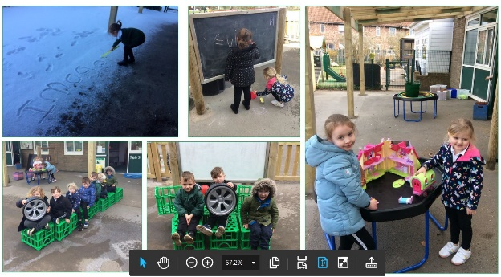
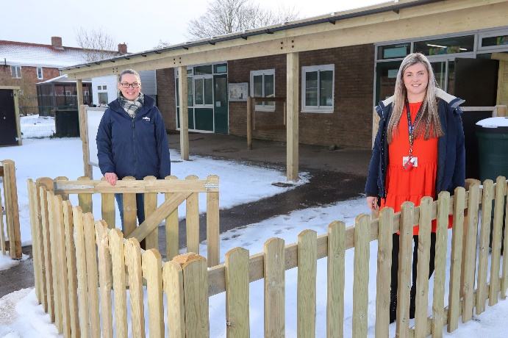
This project was awarded £17,300 in October 2020 to create a weatherproof sheltered area by installing a canopy onto the side of the school building to carry out projects using the outdoor space.
The school council now use the space for new lunchtime friendship activities to improve relationships and confidence and the area will be open for wider community use once restrictions allow.

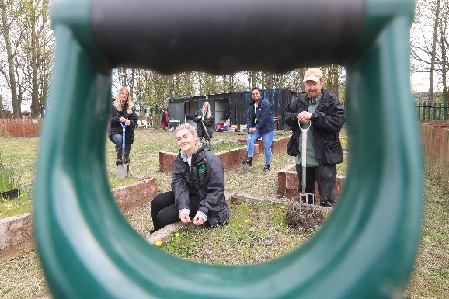
Groundwork North East – Coundon Community Allotment

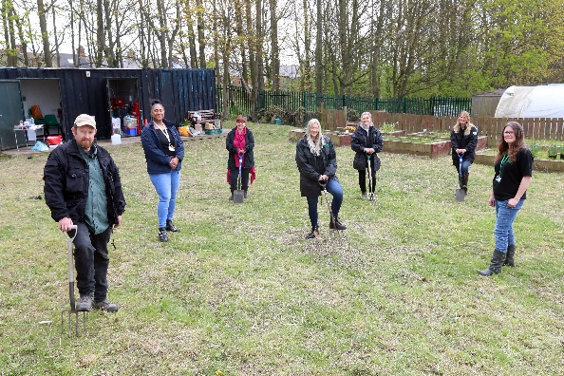
The project, which was awarded £19,792 in October last year, will open up Coundon Allotment as a hub for believe housing customers and their neighbours in Coundon and Leeholme, providing a safe green space and a range of community learning courses.

Funding is being used to install a composting toilet, footpaths, raised beds, seeds, compost, cookery packs, project coordination and session delivery.

Find out more
Full terms and conditions, together with application forms, are available on the believe housing website believehousing.co.uk

For more information on all of believe housing’s grant funding opportunities you can call the Community Investment Team on 0300 1311 999 or email us at CommunityGrant@believehousing.co.uk

